Python and Data Science

Contents

Python and Data Science 3

Anaconda for Data Science 3

Anaconda User guide 4

# Python and Data Science

# Anaconda for Data Science

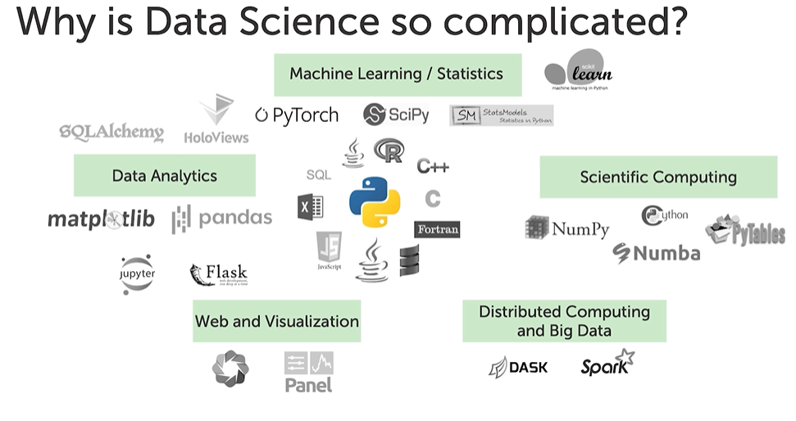

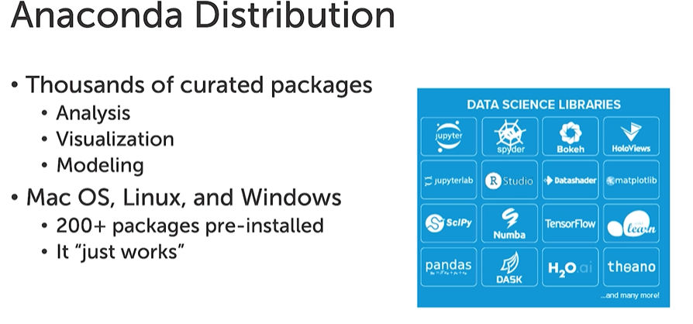

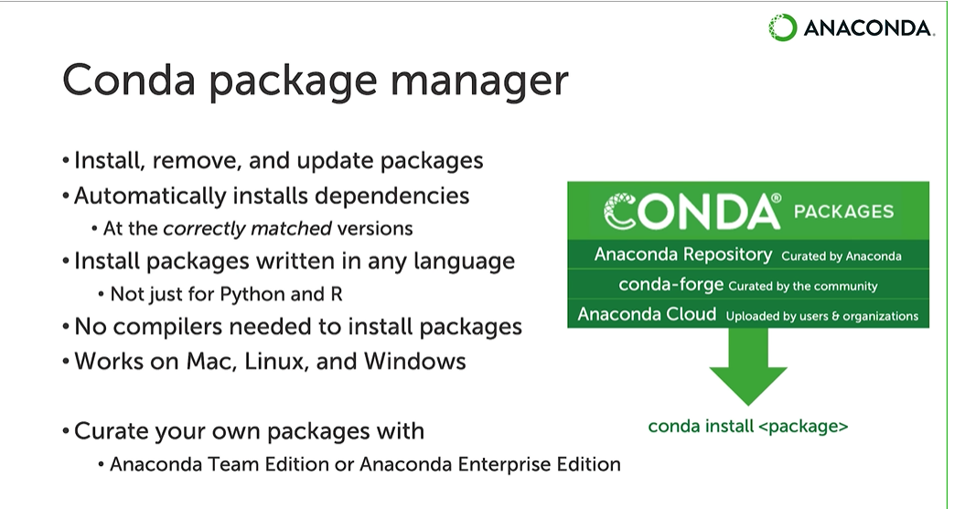

[**https://anaconda.cloud/tutorials/getting-started-with-anaconda-individual-edition?source=win_installer**](https://anaconda.cloud/tutorials/getting-started-with-anaconda-individual-edition?source=win_installer)

# Anaconda User guide

<https://docs.anaconda.com/anaconda/user-guide/?utm_source=anaconda.com&utm_medium=individual-get-started>